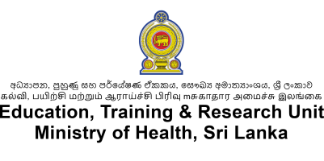 | CPD Programme Format
- Name of Registered CPD Provider
- Name of CPD Programme
- CPD Course | Name:
 | Online Link*:
- Resource Personnel(s) | Content Expert(s)** | Suggested Mentor(s)***
- Expected Target Group
- Expected Output
- Expected Outcome
- Brief Outline of CPD Programme
- Expected CPD Points
- Authorized Signatory of
Registered CPD Provider
OFFICE USE ONLY
- Decision of Accreditation Committee
- Authorize Signatory of
Accreditation Committee:
Instructions
- * Leave blank if no online link is available, ** Holding an MD / PhD in the relevant subject, *** By discipline (e.g. Pathologist, Cardiologist) or designation (e.g. MOH, RE)
- Please register as a CPD provider by filling out the Google form using the link - https://tinyurl.com/mohcpdprv in the Ministry of Health website.
- After registration, please submit this form (one for each course/programme) with the agenda
- To download the agenda format, please click the link - https://tinyurl.com/4z3pmpxb

- Please submit the signed application and agenda form via the Google Form - https://tinyurl.com/3t9bbz7h

- Please post the hard copy to DDG (ET&R), SUWASIRIPAYA, No 385, Rev. Baddegama Wimalawansa Thero Mawatha, Colombo 10

